

An Essay on Price Cointegration in the US Paper Related Market
Sreelakshmi Sajeev

The University of Huddersfield
April 2022

Table of Contents
Table of Contents 2
List of figures 3
List of Tables 4
Abstract 5
1.Introduction 6
2.Motivation 11
3. Literature Review 14
4.Theoretical Framework 18
5.Data and Methods 22
6.Results and discussion 28
7.Conclusion 35
References 36

List of figures

Figure 1:Intermediate and final products of the paper industry 22
Figure 2: Plot of log price v/s time- Wood pulp 23
Figure 3: Plot of log price v/s time- Paper 25

List of Tables

Table 1: Descriptive statistics of products 24
Table 2: ADF Test on the series 26
Table 3: Test statistic- KPSS test 27
Table 4: Zivot -Andrews Unit root test statistic and break position 27
Table 5: Engle-Granger test statistic 29
Table 6:Johansen Test statistic 30
Table 7:VECM model – Wood pulp-paper-newspaper 32
Table 8:VECM model- Wood pulp-Paper-Periodicals 33

Abstract

Empirical analyses of price dependencies in the paper manufacturing sector help to analyze its market developments and the design of efficient utilization pathways. This paper identifies price cointegration between three categories of closely related raw materials (wood pulp, waste paper, paper), and closely related finished products (newspaper, periodicals, paperboard) in the paper manufacturing sector in the US. Why is this worth doing? Daily prices of raw and finished materials between the period 2007-2010 are used for the following statistical tests: (1) The Augmented-Dickey-Fuller, KPSS & Zivot-Andrews unit root tests to examine the stationarity of the data; (2) The Johansen Cointegration test and The Engle-Granger test for determining the cointegration between time series (3) VECM to determine the long and short-run causality between the series. It would be better to state why these methods are suitable/ what they do, in brief, and then to provide some key findings which are missing entirely.

1.Introduction
Markets aggregate demand and supply among spatially dispersed players, and they play a critical role in reducing the risk of demand and supply shocks. Markets help clear markets and identify equilibrium prices and quantities – this is Micro 101. I am not sure how you argue that markets reduce supply and demand shocks. If so, why do we have significant effects of energy shocks or food commodity shocks in international markets including W. Eruope and N. America where we have reasonably efficient markets in operation. Market structure and connections AGAIN – non accurate and colloquial language – please be more precise studies may provide the government with a solid foundation of facts before launching a new strategic approach or defining new performance targets. Economists feel that market pricing has taken centre stage in defining the market (Stiglitz, 1993). Widening price-cost margins signal profit possibilities to which observant entrepreneurs respond. Further, pricing sends information about fluctuating demand and supply situations to producers and consumers. This paragraph gives me no idea of what you wish to do; why it is worth investigating and what your own contribution is likely to be.
Pulp and paper are two of the world's most important and widely traded commodities. Okay – can we provide some data, including more recent data? You could add a picture or table to support your assertion. The pulp and paper market in North America is significant on a worldwide scale HOW?, since the area is the world's largest producer and consumer of paper pulp Okay – but what . According to NAFTA, between 1993 and 2013, the overall value of trading of what? in the United States rose from $16.7 billion to $82.0 billion, a 233 per cent higher when inflation is included in. What is all this referring to?
Foreign direct investment (FDI) in the NAFTA nations' resulted in increased agricultural product sales (Zahniser et al., 2015). The development of an integrated market for forest products is one of NAFTA's and sustainable forestry's aims. What about the actual situation? Given the importance of the pulp and paper trade in the North American market You have not established this at all – how about some sectoral commentary using data, it is critical to comprehend its market behaviour, since changes in the North American market may have far-reaching consequences for global pulp and paper markets. Again – unclear. When it comes to agricultural investments in the US South, wood pellet and related industries have seen an upswing in recent years which may be impacted due to global renewable energy regulations. For instance, European policymakers have offered fiscal incentives to convert energy production from non-renewable to low-carbon sources over the past decade (Lu et al., 2020). According to the US Census Bureau (2017), between 2012 and 2016, wood pellet exports from the US to Europe surged by 56% (from US$267 to US$607 million a year). This period also witnessed new pellet mills emerging on account of the increased demand. Depending on the state in the US South, the overall economic gain from running costs of US$13.8 million might range from US$20.7 million to US$25 million (Henderson et al. 2017). Because their markets overlap, the advent of pellet mills in the US South has resulted in increased competitiveness for raw materials with pulp and paper industries (PPIs) and composite panels. Okay but how does all this link with what you are analysing? I am also not convinced you have done a sufficient industry/ market analysis related to your chosen commodities.

  - Determining factors of paper pricing

Wood's wide availability allows it to be used in a variety of sectors (Giurca, 2020). Globally, demand and competition are driving the increased internationalization of wood product value chains (Bailey et al., 2019). Global production and trade of most major wood products (Roundwood, wood pulp, wood charcoal, and pellets) achieved record highs in 2018, according to the Global Forest Products report (FAO, 2018). According to (Bryngemark, 2019) the competitiveness impact in the wood-related sectors increases competition for raw resources, resulting in higher costs.

In recent years, the prices of raw materials and final products in the paper production business have fluctuated dramatically and experienced steep movements. How about showing a time series graph indicating this volatility? Part of this might be due to the rise in e-commerce, which has resulted in an increase in corrugated boxes and other packing materials (Tokar et al., 2021). Good point – again you could provide some concrete data also about such packaging materials. Fluctuating demand and supply trends can also have an impact on paper pricing. Even though the demand for paper and associated products is growing, records reveal YOU NEED TO CITE YOUR REFERENCE HERE that supply in regions, particularly in the United States, is diminishing due to downscaling of paper production capacity. The paper sector in the United States has seen considerable pricing swings in a short period of six months which six months?, resulting in a 10% drop in total manufacturing capacity. The damage was exacerbated by the shutdown and scaling down of output at major mills such as Georgia-Pacific and West Linn (Fuhrmann et al., 2021). Though recent events such as the Covid-19 pandemic have had major consequences, it might also be because the paper business is heavily influenced by cross-national legislation. For example, new environmental and recycling standards in China, the world's leading paper producer, resulted in increased manufacturing costs, raising worldwide prices for importing nations. In addition, China used to recycle 55 per cent of the world's discarded paper, converting it into cardboard packaging and cartons (Song et al., 2021). However, new environmental restrictions in January of which year? caused Chinese mills to discontinue this method to manage contaminants entering the manufacturing stream. The cost of transportation is another aspect that influences pricing changes. Increases in fuel and freight prices account for a large portion of pricing increases in the paper business (Martino et al., 2009). When there are wars or pandemics, this accelerates on a worldwide scale.

The paper production industry has a lot of demand and supply discrepancies across different product categories. For instance, due to the obvious better margins in corrugated and packaging products, some factories that previously manufactured bond paper moved to corrugated and packaging products. Bond paper prices have risen because of the fall in bond paper manufacturing (Fuhrmann et al., 2021). The inter-relations between different countries’ markets also need to be considered. For instance, the paper industries of China and the US are highly related. Hence, currency changes affect the supply of goods to the US market, resulting in price increases. For instance, manufacturers and employees in the United States have expressed dissatisfaction with China's trade surplus, alleging that the yuan peg has given Chinese firms an unfair edge (Morrison, 2019). Because of the currency disparity between the dollar and the yuan, the price of paper in China is currently higher than in the United States (Zhang, 2000), encouraging suppliers all over the world to prefer selling to Chinese clients. Many businesses are getting intertwined with the forest-based industry, and synergies in the raw material and value chain competitiveness must be explored and evaluated (Giurca, 2020). Hence price dependencies are important to consider when studying forest-based economies. Several studies, such as those (Di Fulvio et al., 2016) and (Verkerk et al., 2019), have been done in recent years to investigate the potential of wood and associated sectors. These studies focus on the availability of wood and its spatial distribution without considering market factors (Fuhrmann et al., 2021). It would help to more carefully structure the literature elements of your analysis, grouping them into distinct factors at play here. You can also use tables to list key papers and their main findings, focusing for example on (i) theoretical papers and (ii) empirical papers.

The paper market is well integrated because the raw materials are extremely geographically reliant UNCLEAR – please be more precise – do you mean tightly globally integreated?, and knowledge of market integration is vital for making appropriate business decisions. Cointegration analysis may be used to investigate future price variations across markets. May or can? Are you referring to what you have done or what you intend to do? Unclear. Sales of raw materials of paper are a significant source of money for forest investors and owners, it is crucial to keep track of price changes. When regional wood markets are integrated together, a price change in one market impacts the price in the others, and any interconnectedness can help to balance price changes across different markets. Understanding price trend cointegration may aid investors in identifying the best asset prospects for paired trading as well. The degree of market integration may provide insight into wood trade interlinkages and appropriate reactions to changing market conditions to the decision-maker.
  - You can provide a better motivation for the relevance of this methods and application of time series methods, including cointegration analysis and other suitable methods.

  - Paper and intermediate materials

Wood pulp, logging residues and industrial by-products are promising raw materials for paper. Furthermore, enhanced recycling practices encourage a significant per cent of paper products to be reused as well. Sawmills produce sawdust and wood chips as by-products, therefore there are no further purchase expenditures (Fuhrmann et al., 2021). These by-products are regarded as the most lucrative since they are of reasonably high quality and are generated in solid form (Kunttu et al., 2020). These characteristics explain their appeal for use by a variety of sectors, which have previously profited from low pricing. The paper industry acquires a significant share of its raw material from sawmill by-products (Eriksson & Lundmark, 2020). Competition, on the other hand, has been increasing with time, resulting in increased prices in this sector. Prior to the introduction of pellets into the energy market, sawmill by-products were mostly utilised to make paper and paper board. As a result, these sectors were able to determine their own pricing for their raw materials, which had previously been kept low. With the increased demand for pellets, production increased, thus competition and cost as a raw material for the paper industry (Kristöfel et al., 2014). Useful and well-written.

Fewer studies (which ones have done this? cite them) have attempted to determine if distinct pulp and paper markets in the American market exhibit a long run relationship with each other. This is a fundamental need for spatial price parity, as it ensures that no arbitrage possibilities exist. Okay – this is a good point but needs to be further developed. Also, there are many factors that can disrupt the industry from achieving a steady-state equilibrium. For instance, several economical and geographical reasons SHOCKS? may have a significant impact on paper prices. Various studies have been carried out in this regard, for instance, according to Gejdos et al. (2019), the 2008 financial crisis had a significant impact on wood markets and pricing in previous decades. Occurrences such as windthrows and bark beetle outbreaks are two more possible market impacting factors (Gejdoš & Suchomel, 2016). External shocks, such as natural disasters, can quickly increase market volatility Okay but this directly contradicts the claim you made in your first para about markets smoothing out shocks (Kristöfel et al., 2014). Further, the North Pacific Paper Co. (NORPAC) filed a petition with the United States International Trade Commission (USITC) on Aug. 9, 2017, alleging that Canadian manufacturers were dumping uncoated groundwood paper (UGW, or newsprint) and that the Canadian and provincial governments were subsidizing it (Beaulieu, 2018). How is this relevant here?

2.Motivation

Use present continuous tense if possible please, not past tense, and don’t refer to yourself in the third person.
Why are parts of this not in the intro? This study is driven by a strong desire to investigate how the US paper market operates as a price-leading market. With the US being the world's second-biggest paper-producing country and one that houses the world's largest paper-producing firms, we aim to investigate degree of market connection and how quickly a group of related paper-product prices converge. Further, rather than just recognizing a long-run correlation, an estimate of the convergence rate aids insight into the informational efficiency (Pesaran & Shin, 1996). Badly argued – rewrite. We investigate whether the degree of market connection may be measured by the pace of convergence and that a parallel analysis of the causing elements can provide a complete view of the problem. Again – confusing and badly drafted line. A recent study by Størdal et al. (2021), mentions that when the WHO announced the Covid 19 pandemic, the forestry subsector was hit more than the paper subsector, according to an event-study analysis of the forest products business in North America. During the year 2020, the systematic risk for the forestry subsector rose until October (source?). This influence was especially noticeable in American forest-related industries. The impact on the paper industry, on the other hand, was more consistent. We wish to identify why the pulp and paper industry reported a favourable impact irrespective of the adverse effects of the Covid 19 epidemic which had a significant impact on all sectors of the wood value chain.

Economists have found significant economic parallels between the coronavirus illness (COVID-19) and the 2008 "Global Financial Crisis" (GFC) or the economic recession (Strauss-Kahn, 2020). Varying from disruption in global supply chains, drops in the stock exchanges, in both the scenarios uncertainty and other concerns surfaced in the world's two largest economies, China and the United States, and then extended worldwide. I disagree – the GFC did not have a massive impact, at least initially, on China. Both of these occurrences can be classified as having a non-quantifiable risk that is difficult to trace, making their likelihood of occurrence and impact difficult to anticipate. Again you contradict your first para where you claimed markets reduce shocks. The World Pandemic Uncertainty Index, developed by the International Monetary Fund (IMF), and the Index of Global Economic Policy Uncertainty (GEPU), the latter of which stands at 348, are both above previous highs: those of the Great Recession (202 in October 2008), the European Sovereign Crisis in 2011 (similar), the Brexit Referendum (228 in June 2016) and US elections (235 in November 2016), and the Trade War, once again between the US and China (up to 342 mid-2019). The first reductions in major country stock markets (up to one-fourth of their value) were comparable to both crises. In addition, both global recessions have been dubbed the worst since the Great Depression (Chan, 2020). With the novel dataset (2007-2010) offered by the ‘Billion Prices Project’ by the MIT, the author is keen to analyse the market integration and cointegration between prices in the paper industry which covers the global recession period, hoping to carry out similar research and compare the results for the COVID-19 period.
I cannot understand the structure of your paper – random things appear (which may be relevant) but I am not sure why you present certain things in certain ways.

Again why isn’t some material from this para in your intro? The purpose of this research is to examine US paper markets with a focus on intermediate material and end-product pricing. Price data is frequently available in adequate temporal precision and timeframe for the forest-based industry. Meaning what? This type of data can be used to forecast market movements in the future (Kolo & Tzanova, 2017). Is this what you are doing? Suitable time series methods and other econometric methods will be used to examine market impacts and interconnections. The findings reveal information on the paper manufacturing industry's costs, interconnections, and interdependence. Okay but what are your identified research gaps? What are you doing that has not been done before? We are on p. 14 and I am still unclear. The goal of this paper is to uncover cointegrating relationships between four pairs of raw and finished paper products. The main aims are to (I) empirically analyse pricing configurations and influencing variables in the paper sector MAKES NO SENSE AND IS WRONG – YOU ARE NOT DOING EXPERIMENTAL WORK, (II) discover interconnections and causal correlations between intermediate material and end product pairs BE MORE SPECIFIC – THIS IS TOO VAGUE (III) Identify, investigate and explain any structural breaks identified in the time series. WHY IS THIS RELEVANT? (IV) Identify the factors that aid the comeback. MAKES ABSOLUTELY NO SENSE – WHAT DO YOU MEAN BY COMEBACK? The current study attempts to find answers to the following research questions:
- Which intermediate and final products in the paper industry exhibit cointegration relationships? WHY BOTHER WITH THIS? RQs need to set out the context of what you are doing, why it matters and/ or is relevant? This is unclear.
- What are the causes of structural breaks, if any, in the time series between 2007 and 2010? Okay – how will you identify these and why do we care? You can argue all this.
- What is the level of market integration in the paper industry; (special focus on structural break and comeback of prices to the equilibrium level) Okay – how will this be measured?
- Using VECM, what are the long and short-run causality exhibited by intermediate and final products? Jargon – what are you investigating in the main?
The points above are methodological points – they state what you will do empirically and cannot really be considered to be RQs. They all need rethinking. Points (I)-(IV) on the last page and (1)-(4) above also don’t line up exactly – why are there discrepancies?
More seriously you have not developed these partial RQs in your previous litt review or preceding analysis in a convincing manner.
The paper is structured as follows. The next section critically evaluates and discusses literature and past research on the subject. Section 5 explains the data and methods. In section 6, the findings are discussed, followed by a conclusion and remarks.

3. Literature Review

Your sections 2 and 3 can be merged. Avoid repetitions and provide clear RQs/ research gaps.
REPEATED MATERIAL – you make similar points in Section 2: In the United States, the forest products industry has long been one of the most important manufacturing industries. The paper, timber, and furniture industries are all part of it (Mei & Sun, 2008). The United States possesses the world's fourth-biggest forest estate, accounting for around 8% of all forest land. Forests in the United States comprise around one-third of the country and are estimated to cover 304 million hectares (Tidwell, 2016). With over 15.4 million acres of privately owned pine plantations, the region is one of the world's largest and most profitable commercial plantation areas (USDA Forest Service, 2019). Conifer industrial Roundwood output was predicted to reach 175 million m3 in 2015, with the wood pulp industry using the lion's share (about 71 million m3 plus residuals). The second-largest user of conifer Roundwood is the conifer sawmill industry, with roughly 61 million m3, followed by plywood and wood pellet producers (Chudy & Hagler, 2020), whose residuals are major raw materials for the paper industry. It would have made sense to provide an overview of the US paper and related market in one subsection rather than intermittently bring random points here and there.

In agriculture, there is a large literature on spatial price transmission, including many econometric methodologies to test for market efficiency and cointegration. Economists have looked at the spatial patterns of pulp and paper exports from the United States (Buongiorno and Uusivuori 1992), Canada (Alavalapati et al., 1997), US-Canada (Tang & Laaksonen-Craig, 2007) in the forest sector. Market research revealed that the pulp and paper import and export sectors in the US are cointegrated. The majority of markets for US pulp and paper exports are cointegrated, according to Buongiorno & Uusivuori, ( 1992). For specific types of paper, Kainulainen and Toppien (2006) discovered pricing consistency throughout Europe's major marketplaces. Changes in supply or demand in one market impact the price in the others because of market integration. Pulp and paper from different nations are predicted to have close price integration as the most traded product on the worldwide market. Prestemon & Holmes (2000) show that market prices are so well matched that changes in import prices of a specific pulp and paper product from one nation have an instantaneous impact on prices of the same goods from other countries.
Previous studies tried to establish interlinkages between different US forest product markets. However, discrepancies in the results are evident. According to (Kolo & Tzanova, 2017), the interdependence of forest product markets is increasing as a result of globalisation. Palander et al. (2002) claim the existence of LoP in the forest sector which is rejected by Eriksson & Lundmark, (2020) who further claims that price affecting policies only have national implications. Chudy & Hagler (2020) discovered that neither worldwide markets of coniferous nor non-coniferous wood products are integrated. Eriksson and Lundmark (2020) further demonstrate that different markets are incapable to counteract price fluctuations and offsetting price shocks. The interrelationship between raw materials and finished products is examined only by few studies. Conrad & Bolding (2011) rejected the possibility of dramatic price changes in the wood and related markets, however, subsequent studies forecasted competition and higher costs for raw materials in the future (Nepal et al., 2018). Previous research has revealed that wood prices in the US South are interrelated across markets. According to Yin et al. (2002), there are at least three big marketplaces in the US South where pine saw timber and pulpwood prices act similarly. Hood and Dorfman (2015) examined a dynamic market connection in the US South, with market clusters developing and dissolving over time. Kanieski da Silva et al. (2019) looked at saw timber markets and claim that it is unclear whether a specific industry, such as pellet mills, may influence the pulpwood stumpage price connection. Further, pulpwood markets have received little attention, with most studies taking place in the early 2000s (Yin et al., 2002). Since then, the timber industry has seen significant transformations, including the 2008 crisis and the development of a significant bioenergy sector.

The paper industries continue to play an essential role as regional economic drivers, as natural resource-based businesses that produce in-demand products (Duden et al., 2017). Despite a significant recession and its aftereffects that occurred over the time period, the total economic output of South Carolina's forestry industry has climbed (Khanal et al., n.d.)
by more than $3.6 billion over the previous decade (Dahal et al., 2015). No previous academic research in the paper and pulp sector has extensively explored the link between raw materials and final products throughout all states, to our knowledge. This study is thus particularly significant for the United States, which is one of the largest producers and users of paper and associated products. Further, several studies have looked at the forest economy's economic significance in a global framework (Crabtree, 2015). Fewer research has looked at this in a domestic setting, and several have produced results in a very confined, single state (Jolley et al., 2020) or at a regional level (Dahal et al., 2015).

Market integration studies can reveal what occurs when a random shock hits the system's long-run equilibrium connection, as well as how quickly the system recovers to equilibrium. It will be interesting to explain the reasons that caused the shock and the factors which resulted in market resilience or that have accelerated or delayed the comeback. If a market takes a long time to return to its long-run equilibrium after a break, it may be sensitive to disruptive shocks (Martin & Sunley, 2014). In this case, the global market's trade policy should be altered to balance the effects. In addition to market integration, global producers and policymakers would benefit from a better knowledge of pricing trends among many associated items in the market. Given that the United States is both one of the world's largest users and manufacturers of pulp and paper goods, the impact of US domestic prices on the worldwide market might be substantial. Also, global policy changes in turn result in considerable fluctuations in the market integration of US paper production. (Kainulainen & Toppinen, 2006) examined the light-weight coated paper and uncoated wood-free office paper markets in Euros per ton in three European markets: France, Germany, and the United Kingdom. Their findings show that the degree of market integration is linked to the advent of the European currency union and is strengthened as a result.

Newsprint paper mills all throughout North America have battled to stay viable in a market where conventional print media is gradually being overtaken by digital media (Durocher & Higginson, 2019). The COVID-19 epidemic impacted a variety of businesses, including the timber industry. According to a recent analysis by the Food and Agriculture Organization (FAO 2020), the epidemic wreaked havoc on the wood value chain. However, the intensity was not uniform across sectors, with the pulp and paper industry reporting a favourable impact (Strdal et al., 2021). This is possible because the forest products business is diversified and interconnected with many markets and value chains on both the demand and supply sides. Since 2000, the forest industries have been in a phase of change, with the global forest sector's economic development becoming more unpredictable and the drivers becoming more diversified than prior. Several internal and external forces, such as globalisation, global climate change, and worldwide rules and regulations, influence changes in forest sectors (Jonsson, 2011). According to Hurmekoski & Hetemäki (2013), the digitization of media has resulted in stagnation or even a drop in income for printing paper, resulting in a significant reorganisation of the worldwide paper sectors.

However, data from earlier in the decade contradict this theory. According to Sun and Zhang (2001), forestry-related assets are little connected with financial markets and have low systematic risk. However, events such as financial crises and pandemics affect different value chains in different ways. The market for sawn wood, for example, is more cyclical than the market for paper, and it was hit harder by the global financial crisis, though it has since recovered. Housing development in the United States plummeted by about 80% between 2006 and 2009 owing to the global financial crisis (Størdal et al., 2021), according to Ince and Nepal (2012), while the global output of wood-based panels declined by 15.6 per cent between 2007 and 2009. Data for the time following the financial crisis, from 2009 to 2019, reveal that worldwide output growth for paper and paperboard was just 9% in contrast to 36% for wood panels (Food and Agricultural Organisation, 2021).
This section is not fit for purpose.
You need to think of clear research strands emerging in your Sections 2 and 3, avoid repetitions and reconsider the structure of your litt review. You should include a succinct and clear overview of the US paper and related market with suitable data – that can be your Section 3, after your litt (or before).
You need up to date and complete references.
You should clearly distinguish between empirical and theoretical papers.
A KEY LIMITATION IS I CANNOT IDENTIFY ANY THEORETICAL OR CONCEPTUAL FRAMEWORK FOR YOUR RESEARCH AND YOU DON’T SET OUT ANY CLEARLY ARGUED TESTABLE HYPOTHESE FOLLOWING A CLEAR LITT REVIEW. THIS IS A MAJOR LIMITATION. I AM NOT SURE YOU UNDERSTAND THE BASICS OF MICROECONOMIC THEORY – YOU NEED TO CARRY OUT DETAILED BACKGROUND READING TO COME UP TO SPEED.

4.Theoretical Framework
Market integration is one of the most significant components of market structure. How is this defined? Markets, in general, are where prices are driven (Stigler & Sherwin, 1985), and studying price changes within a market is an important part of understanding market structure. In the long term, the more near-perfect a market is, the stronger the propensity for identical product prices to move together (Stiglitz, 1993). In the case of pulp and paper import markets in the United States, there are two important components of market integration: (I) the long-run equilibrium connection between the pricing of raw material- finished product pair (II) the rate at which prices return to their long-run equilibrium after being disturbed by certain shocks, which might be caused by changes in policy, technology, or market forces as identified in the literature. YOU FIRST NEED TO SET OUT YOUR THEORETICAL FRAMEWORK – WHERE IS IT? YOU NEED TO PROVIDE CLEAR DEFINITIONS OF BASIC TERMS YOU ARE USING – THIS IS ABSENT.
I AM NOT SURE YOU UNDERTAND WHAT IS MEANT BY A THEORETICAL FAREMWORK – A DETAILED DISCUSSION OF ECONOMETRIC METHODOLOGY IS NOT ON ITS OWN AN ADEQUATE CONCEPTUAL FRAMEWORK.

If stationarity characteristics are disregarded, OLS can be unreliable (Granger, 2004) as spurious regressions may mistakenly indicate a relationship between the variables where they are independent of each other. This may be fixed by confirming the residual's stationarity. If the residual is nonstationary, the regression is invalid (cannot reject the null hypothesis of the unit root test) (Engle & C. W. J. Granger, 1987). A series, $M_{t}$,exhibits weak stationarity if its mean and variance remain constant over time,
E ($M_{t}$) = μ
var ($M_{t}$) = σ2

and strong stationarity if the covariance between two values from the series is determined only by the amount of time between the two values, rather than the actual times at which the variables are measured.

cov ($M_{t}$,$M_{t+s}$) = cov ($M_{t}$,$M_{t-s}$) = $∂$s
MUCH OF THIS NEEDS TO MOVE TO YOUR METHODOLOGY SECTION!
Logarithms and other transformations can aid in the stabilisation of a time series' variance. By removing shifts in the level of a time series and so eliminating (or lowering) trend and seasonality, differencing can assist in stabilising the mean of a time series. A non-stationary series is said to be integrated of order d if it must be differenced d times before it becomes stationary. This can be demonstrated as,

${∆M}_{t}=$ ${∆M}_{t}$ - ${∆M}_{t-1}$

where $m_{t}$ is a non-stationary series and ${∆M}_{t}$ is the differenced series. The first series is referred to as "integrated of order one" or I(1).
WHAT IS THE SOURCE FOR ALL THIS? CITE IT PLEASE. When a linear relationship can be established between two random walk series, it marks a significant exception to the spurious regression. In such cases a value, $β$, exists such that,
$M_{t}$-$βN_{t}$ , is integrated of the order 0 or I(0) where
$M_{t}$and $N_{t}$ are integrated of the order 1 or I(1)

In such circumstances, a cointegrating relationship between $m_{t}$ and $n_{t}$ can be established. This is also workable even if only one of the series is I(0) and the other series is I(1). Because it converges to $β$ at a significantly quicker pace than standard asymptotics, the OLS estimator b is considered to be super consistent for $β$. $β$ will be the cointegrating parameter. In the regression,
$M_{t}$ =α+β$N_{t}$ +εt, where $M_{t}$ and $N_{t}$ are both (I) and the presence of $β$ such that
$P_{t}$= $M_{t}$ – β$N_{t}$ is I(0) can establish a cointegrating relationship.
$M_{t } and N_{t }are characterised by long wave components as they are integrated of order 1.$This components are absent in $P_{t}$ as this is I(0). Ideally, $P_{t}$ is produced by the 'long wave' components cancelling out perfectly. An equilibrium error which can be defined as, $p_{t}$= $P_{t }$– a, is the measure of the deviation of a series $M_{t}$ from the equilibrium,
$M_{t}$ =a + b$N_{t}$.
- The equilibrium error is steady and fluctuates about zero if $p_{t}$ is I (0). As a result, the system will be in equilibrium on an average.
- If, on the other hand, $M_{t}$and $N_{t}$ are not cointegrated and $p_{t}$is I(1), the equilibrium error might be large and zero-crossings are uncommon.
As a result, the presence of a cointegrating vector (1-$β)'$might be regarded as a long-term relationship indicating $M_{t }and N_{t}$ are cointegrated.
WE DON’T NEED THIS LEVEL OF DETAIL FOR BASIC STUFF WHICH IS TEXTBOOK AND ESTABLISHED SOMETIMES EVEN AT UDNERGRADUATE LEVEL.
We aim to identify cointegrating relationships between three pairs pf intermediate and final products in the pulp and paper industry. WHY? What is the reason for doing this? Several studies have established such a relationship between products on a cross-country analysis, the current paper tries to identify these within a single country set-up.
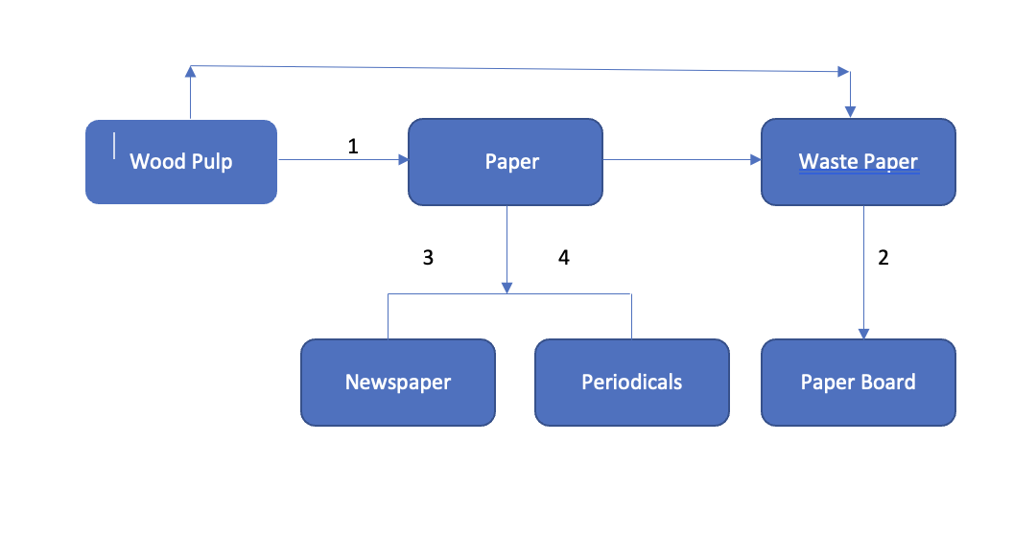
Figure 1:Intermediate and final products of the paper industry I am not convinced of the relevance and/ or accuracy of this – needs revisiting.

Wood pulp is made from raw wood, which is the main material used by paper producers (Nycz, 2019). Softwood coniferous trees account for 85 per cent of the wood pulp used in the United States that have longer fibres, which are believed to make the paper stronger. Corrugated boxes are well-liked items that are frequently utilised as shipping containers. Tissue, printing and writing papers, paper board, and speciality papers for journals and magazines are four of the most common end products for wood pulp. Based on the end application, each has distinct fibre needs (Cord, 2021). The study aims to find cointegrating relationships between the pairs of wood pulp-paper, wastepaper- paperboard, paper -newspaper, paper- periodicals as shown in figure 1. You still need to (a) establish why we expect these to hold – partly done above and (b) more importantly why we should care for all this?

5.Data and Methods

Daily prices of paper-related products’ raw and finished products from 2007 to 2010 were obtained from the Billion Prices Product data. URL/ REFERENCE? ‘The Billion Prices Project IS an academic initiative at MIT and Harvard that used prices collected from online, offline and multichannel retailers across several countries on a daily basis to conduct research in macro and international economics’ (BPP, 2008). Time series analysis enables the optimal monitoring and control of a system's performance over time by allowing for the description of fluctuation in variables of interest over time, a better understanding (or explanation) of the data-generating mechanism, and the ability to predict future values of a time series (Chatfield, 1989). WHY CAN’T YOU DISCUSS YOUR BASIC METHODLOGY IN A CLEAR SUB-SECTION HERE? THAT WOULD MAKE MUCH MORE SENSE. The study's primary goal is to discover and explain structural changes, hence high-frequency data was used.

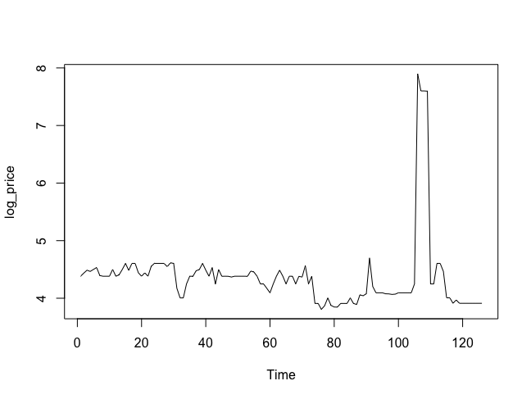
Figure 2: Plot of log price v/s time- Wood pulp WHAT IS THIS SHOWING? WHY HAVE YOU NOT PROVIDED A DATE LABEL ON THIS X-AXIS – THIS IS LAZY WORK. TIME SERIES WITHOUT DATE LABELS ARE VERY HARD TO INTERPRET.
WHY HAVE YOU NOT PROVIDED COMMENTS ON FIGRUES 2 AND 3? WHY IS THERE A SPIKE IN FIGURE 2? THIS IS A SERIOUS OMISSION – YOU CANNOT INCLUDE FIGURES AND TABLES ETC WITHOIT COMMENTING ON THEM FULLY.
When the exact timing of a shock is known, high-frequency data allows us to pinpoint the exact moment of the incident and, as a result, accurately identify market players' reactions. THIS MAKES ZERO SENSE – IF YOU ALREADY KNOW WHEN A SHOCK HAS OCCURRED THEN WHY DO YOU NEED FURTHER ANALYSIS OR FURTHER DATA TO AS YOU SAY PINPOINT IT? This method does have the benefit of being quick and simple to adopt (Ferrari & Ters, 2017). Of the FEW different countries available IN BPP, the US HAS BEEN selected due to its high price fluctuations and downscaling of paper manufacturing industries during the period identified in the literature review. Products were identified using the COICOP codes of the year 2006. The products selected for our study (with the COICOP codes) are, respectively, wood pulp (911), waste paper (912), paper (913) for raw materials and paperboard (914), newspaper (931) and periodicals (932) for finished products. Within this group, four raw material-finished product pairs were identified. The time series pairs thus identified are from the paper industry and they are wood pulp-paper, waste paper- paperboard, paper- newspaper, paper- periodicals. The daily prices were converted to weekly prices to reduce the number of data points. OKAY BUT FULL DETAILS ARE NEEDED.

Table 1: Descriptive statistics of products

Table 1 shows the descriptive statistics of the products used for the study. As per the table, both intermediate and final product prices have varied significantly during the study period. MAKES NO SENSE – WHAT ARE YOU REFERRING TO? YOU NEED TO REFER TO PRECISE STATS. YOUR TABLES ARE VERY POORLY FORMATTED. WHY DO YOU NEED SO MANY DECIMAL PLACES FOR EXAMPLE? WHY NOT REPORT TO 2 OR 3 DECIMAL PLACES? When compared, the intermediate product prices have more variation with wood pulp and wastepaper prices fluctuate the most. UNCLEAR SINCE YOU USE VAGUE LANGUAGE. The final products didn’t exhibit much variation where the paper board has shown the most fluctuations with a coefficient of variation (CV) equals 102.697 whereas the newspaper has shown the least changes in prices (CV=14.519)
YOU NEED TO SEE HOW SUMMARY STATS ARE COMMENTED ON.

Figure 3: Plot of log price v/s time- Paper WHAT ABOUT THE OTHER SERIES?

AGAIN? YOU NEED ONLY ONE METHODS SUB-SECTION!!!! Time-series studies are used to learn about a series' structure and influencing factors, as well as to develop a model that may predict its future trends. A time series must be stationary, which means that its first and second moments (mean and variance) do not fluctuate with time (Schreiber, 1997). REPEATED – VERY OLD CITATION. Traditional regression analysis may easily examine the possibility of a structural change in demand by providing estimates of various elasticities. The likelihood of nonstationarity of the variables is a specific problem for regression analysis employing time series data. Nonstationarity (as induced by unit root, for example) can lead to misleading regression due to faulty t-statistics (Fuhrmann et al., 2021). AGAIN? WHY? The study analyses three unit-root tests, ADF, KPSS and Zivot-Andrews test to detect the stationarity of data.
THERE ARE SOME SERIOUS OMISSIONS:
WHY ARE THESE THREE CHOSEN?
WHAT SOFTWARE HAVE YOU USED FOR YOUR ANALYSIS?
WHICH SPECIFICATION OF THE UNIT ROOT TEST IS MOST APPROPRIATE?
WHAT LAG LENGTHS HAVE YOU CHOSEN? AND HOW?
WHY HAVE YOU NOT GRAPHED ALL SERIES AND COMMENTED ON GRAPHS? DO THESE HAVE TRENDS FOR EXAMPLE?
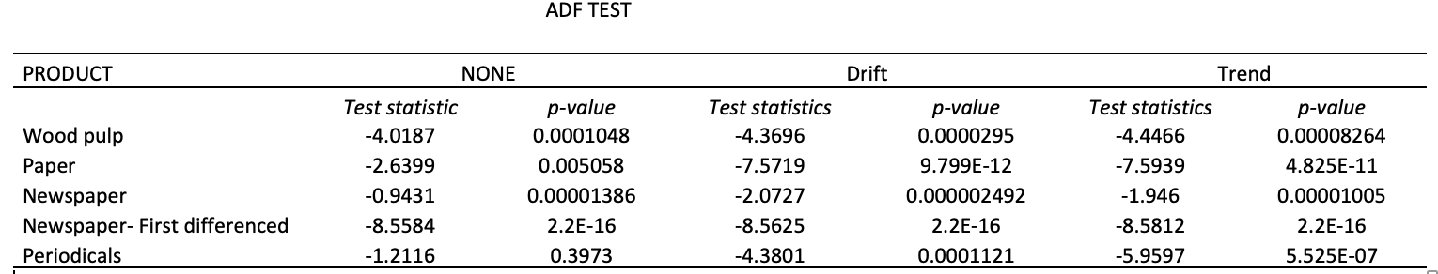
Table 2: ADF Test on the series
Critical Values Of None Are -2.58,-1.95.-1.62, Drift Are -3.46,-2.88,-2.57, And Trend Are -3.99,-3.43,-3.13 At 1%, 5% ,10% Respectively.
WHAT HAVE YOU FOUND IN TABLE 2? WHY HAVE YOU NOT COMMENTED ON WHAT YOU FIND? THIS IS A SIGNIFICANT OMISSION.

YOU HAVE FAILED TO OUTLINE YOUR EMPIRICAL STRATEGY – THIS MEANS THE STRUCTURE OF YOUR DICUSSION IS PROBLEMATIC. WE WOULD EXPECT YOU TO PROVIDE A SET OF COMMENTS ON PRELIMINARIES IE SUMMARY STATS/ TIME SERIES PLOTS ETC; THEN MOVE TO UNIT ROOT TESTS AND DISCUSS YOUR FINDINGS ON UNIT ROOTS AND THEN MOVE TO COINTEGRATION ANALYSIS. I NOTE THAT YOU DON’T SEEM TO HAVE DESCRIBED ALL THESE VARIOUS METHODS YOU CHOSOE FORMALLY IN BRIEF. YOU ALSO DON’T EXPLAIN WHICH OF THESE ARE BEST SUITED (EG WHICH UNIT ROOT TEST IS MOST APPROPRIATE AND WHY?)
While many time series analysis methods need stationary data, cointegration is a concept that allows researchers to mix two non-stationary time series as long as they are in balance across time. Cointegration between pricing is predicted in the paper sector since it is characterised by interconnected markets at many levels, such as intermediate and finished products. The goal of the study is to visualise and explain structural breaks that may occur as a result of disruptions in demand and supply chains that have been documented in the literature. For checking the possibility of cointegration, two tests, Engle-Granger and Johanssen tests have been employed. The "tseries", "urca", and "vars" packages in R Studio are used to conduct the analyses. To ensure that the time series involved in the analysis are non-stationary, the augmented Dickey-Fuller (ADF) unit root test (Dickey & Fuller, 1979), where the null hypothesis (H0) of non-stationarity is tested. The results are supplemented with a Kwiatkowski–Phillips–Schmidt–Shin test, i.e., KPSS (Kwiatkowski et al., 1992), which tests for H₀ of stationarity. NOT SURE OF RELEVANCE – THIS NEEDS RETHINKING AND REWRITINGG. IT IS ALSO UNUSUAL TO MIX METHODLOGY AND RESULTS IN THIS WAY.
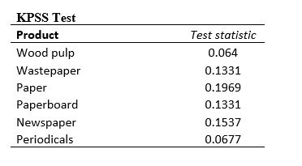
Table 3: Test statistic- KPSS test
critical values are -0.119,-0.146,-0.176,-0.216 at 10%, 5%, 2.5% and 1% respectively
WHAT DO YOU FIND? THERE IS NO DISCUSSION SO WHY HAVE YOU INCLUDED THIS TABLE 3?
Finally, the Zivot and Andrews test is used, which allows the time series to detect one break endogenously(Zivot & Andrews, 1992). FINDINGS?
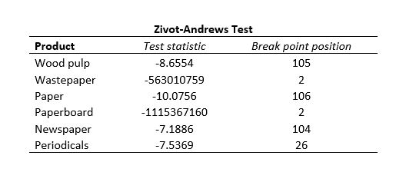
Table 4: Zivot -Andrews Unit root test statistic and break position
critical points are -5.57, -5.08, -4.82 at 1%, 5%, and 10% respectively.
AGAIN - AT DO YOU FIND? THERE IS NO DISCUSSION SO WHY HAVE YOU INCLUDED THIS TABLE 4?

The cointegration between the series is tested using Engle-Grange (Engle & Granger, 1987) and Johansen (Johansen, 1988) tests. FRAGMENT – WHY IS THIS HERE? YOU PROVIDE NO DISCUSSION AT ALL HERE.

6.Results and discussion

FULL OF REPETITIONS.
Previous research on paper and paperboard demand have overlooked the issue of stationarity; nevertheless, a number of other studies have used non-stationary data approaches to investigate the pulp market and paper imports. (Sarker, 1996) investigated the impact of price, income, and other variables on Canadian softwood lumber exports to the United States using co-integration analysis. To anticipate the price of Danish lumber, Riis (1996) used an error correction model. (Alavalapati et al., 1997) looked at the factors that influence the pricing of pulp in Canada. Short- and long-term export demand for Finnish printing and writing paper in the United Kingdom was assessed by Laaksonen et.al (1997). WHY IS ALL THIS NOT IN YOUR LITT SECTION?

We cannot reject the null hypothesis for the prices using ADF testing at the 5% significance level, hence they are all described by an I(1) process (non-stationarity). YOU HAVE PROVIDED NO COMMENTS ON THE ADF TABLE – WHAT PRICE SERIES IS THIS RESULT FOR? The null hypothesis (stationarity) was rejected at a 5% level of significance in the KPSS test indicating the non-stationarity of the series. UNCLEAR – YOU NEED TO COMMENT ON SPECIFICS FOR EACH INDIVIDUAL SERIES. A unit root process with a drift that eliminates external structural change is the null hypothesis of Zivot Andrews. The null hypothesis cannot be ruled out in this study, implying that prices tested are non-stationary and may be subject to structural changes. UNCLEAR AND VAGUE. For wood pulp and paper, structural breaks are detected at the end of the series. WHAT PERIOD ARE BREAKS IDENTIFIED FOR? YOU NEED TO LIST THEM.

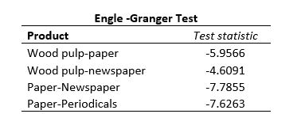

Table 5: Engle-Granger test statistic
H0=no cointegration rejected at |test statistic| >1.96
SHOULDN'T THIS BE IN YOUR METHODS/ RESULTS SECTION? WHY YOU NOT FOR A CLEAR SECTION FOR EMPIRICAL ANALYSIS, AFTER A SENSIBLE METHODLOGY SECTION?
In the United States, log prices rose modestly in 2006 throughout 2007, peaking at 71 US$/m3 in 2007 during the housing boom, before dropping to 60 US$/m3 by early 2009 owing to a deepening recession (Howard & Products, 2007). Following the 2008 housing crisis in the United States, log prices plummeted(Chudy & Hagler, 2020), but this trend was reversed in 2009 when China began to purchase both conifer logs and lumber from the United States (Singh, 2021). Because the variables are integrated in the same order, the Engle - Granger approach is used to run a cointegration test between each pair of prices. The null hypothesis of no cointegration is investigated using pairwise analysis. Cointegrating correlations between woodpulp-paper, woodpulp-newspaper, paper-newspaper, and paper-periodicals pairings have been discovered. Both trace and eigen value Johansen tests reveal cointegrating relationships between woodpulp-paper-newspaper and woodpulp-paper-periodicals groups. I AM NOT SURE YOU ARE AWARE OF OR UNDERTAND THE CRUCIAL DIFFERENCE BETWEEN CORRELATION AND CAUSALITY. IN THE JOHANSEN PROCEDURE WE ARE CHIEFLY INTERESTED IN LONG RUN CAULSAITY NOT SIMPLY CORRELATIONS.
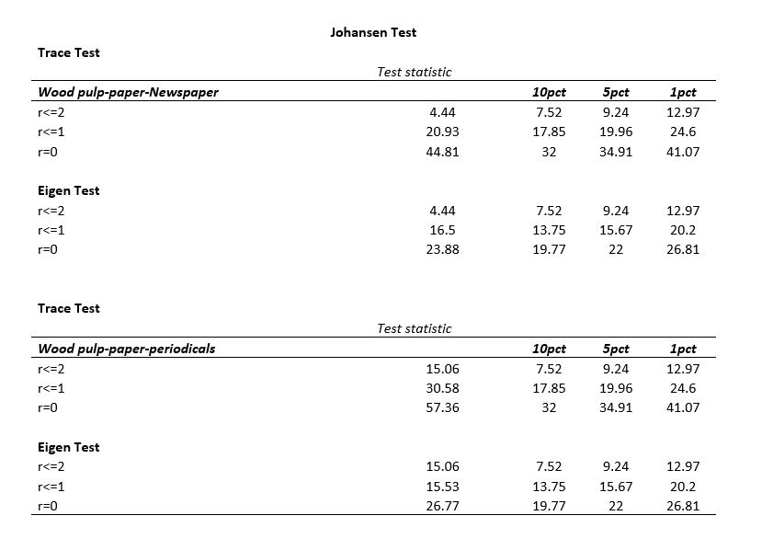
Table 6:Johansen Test statistic
H0= no cointegration is rejected at |test statistic| > 5% critical value
WHAT IS THE SPECIFICATION YOU EMPLOY, WHAT DO YOU FIND AND WHAT DO YOU INFER FROM THESE RESULTS? WHAT SOFTWARE HAVE YOU USED FOR THE TABLE ABOVE?
Structural breaks and structural breaks can be caused by a variety of factors, including (a) legislative/policy changes, (b) economic evolution, (c) technical progress, and (d) political turbulence or war. WHAT BREAKS HAVE YOU IDENTIFIED – YOU DON’T SEEM TO IDENTIFY THE PERIODS. WHY HAVE NOT SHOWN ZA TEST GRAPHS? This can result in stochastic patterns. Nonstationary in the oil and gas markets, as well as natural resource markets, can be induced by structural changes (Wang et al., 2021). Over the last decade, the timber market in the US South has attracted international investments in wood pellets. The growing demand for biomass has driven pellet mills to consume pulpwood in order to complement the shortage of wood residuals (Kittler et al., 2020). This demand can change not only pulpwood prices but also how markets are linked spatially. A VECM is used to continue with the cointegration analysis. The Akaike information criterion is used to choose the number of lags in the models. Long term cointegrating relationships have been identified between intermediate and final products in the paper industry.
The economic recession in 2008 partially explains the increase in pulpwood supply; prices of sawtimber were severely affected by the collapse of the housing market (Ince and Nepal 2012). The ratio between saw timber and pulpwood (softwood) prices decreased from 5.3 to 2.6 between 2005 and 2013. Consequently, producers often have opted to intensify thinning or postpone harvesting until sawlog prices recover thereby hardwood pulpwood demand declined in the US South by 8 million tons (20 per cent) at the beginning of 2007. Subsequent damage is caused by recession and oil shock prices (James D. Hamilton, 2009).

The VECM (Vector Error Correction Model) compensates for both short-run and long-run changes in variables as well as variations from equilibrium. FLAWED – YOU NEED TO BE MORE CAREFUL IN YOUR DISCUSSION OF METHODS. VECM models can analyse both long and short term equations, but also the number of co-integrating connections. POOR TERMINOLOGY – YOU SHOULD REFER TO RELATIONSHIPS NOT CONNECTIONS. YOU NEED TO READ ECONOMETRICS TEXTBOOKS CAREFULLY. The resultant VAR from VECM representation provides more efficient coefficient estimations, which is a benefit of VECM over VAR. UNCLEAR. The long-run connection is represented by the error correction term. The presence of a long-run causal link is shown by a negative and strong coefficient of the error correction term. YOU HAVE NOT ESTABLISHED THIS – WHAT IS RELATED TO WHAT? WHAT IS YOUR IDENTIFIED LR RELATIONSHIP? WHY HAS IT NOW BEEN SHOWN? YOU DON’T EVEN DEFINE YOUR RANDOM CODE BELOW PRICE911/ PRICE 913 ETC – HOW ARE WE SUPPOSED TO FOLLOW WHAT YOU ARE DOING?
LAZY WORK BELOW – WHY ARE PRICES NOT NAMED IN A WAY WE CAN UNDERSTAND?
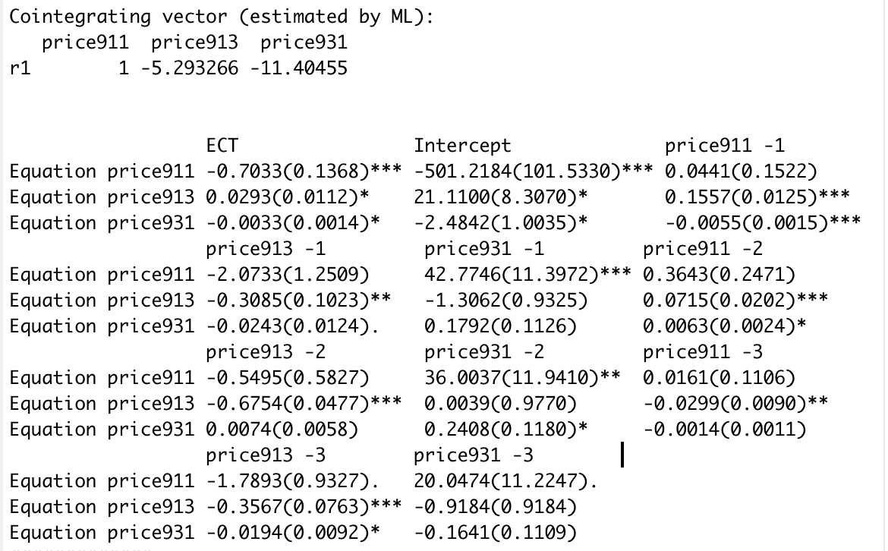

Table 7:VECM model – Wood pulp-paper-newspaper
(*=significant at 5%,**significant at 1%, *** significant at .01%)
NO IDEA WHAT YOU FIND AND WHAT’S GOING ON.
The VECM is used to address the disequilibrium in cointegration relationships and to assess for long and short-run causation among cointegrated variables. The mean of the Error correction term is used to rectify the disequilibrium (ECT). Out of the three variables, the price of wood pulp (price911) is the dependent variable (r1=1) and the price of Paper (price913) and Newspaper (price931) are independent variables. The ECT is significant at 5% for paper (2.9%) and newspaper (0.3%) indicating a long term causality. OKAY THEN WHT IS YOUR LR EQUATION? AND WHAT DO YOU INFER FROM THE ECT? UNLCEAR. The coefficient of lag 1 of wood pulp is 0.0441 but it is not significant. Similarly at lag 2 (0.3643) and 3 (0.0161). Out of 3 lags of wood pulp, there are no significant values indicating the absence of short-run causality of its own lag on wood pulp. Similarly, for paper and newspaper, the absence of short-run causality of its own lag is indicated by the absence of significant values. OK. WHAT CAN YOU SAY ABOUT THE SPEED OF ADJUSTMENT OVERALL FOR YOUR RESULTS? NEEDS TO BE CLEARLY DISCUSSED.
HOW WERE THESE LAGS CHOSEN? YOU DON’T SEEM TO REPORT ANY AIC VALUES. However, in the case of wood pulp (price911) and newspaper (price931) out of three lags, two values are significant, indicating short-run causality on wood pulp derived from the newspaper. In case of cwood pulp (price911) and paper (price913) out of three lags, no values are significant, indicating no short-run causality on wood pulp derived from paper.
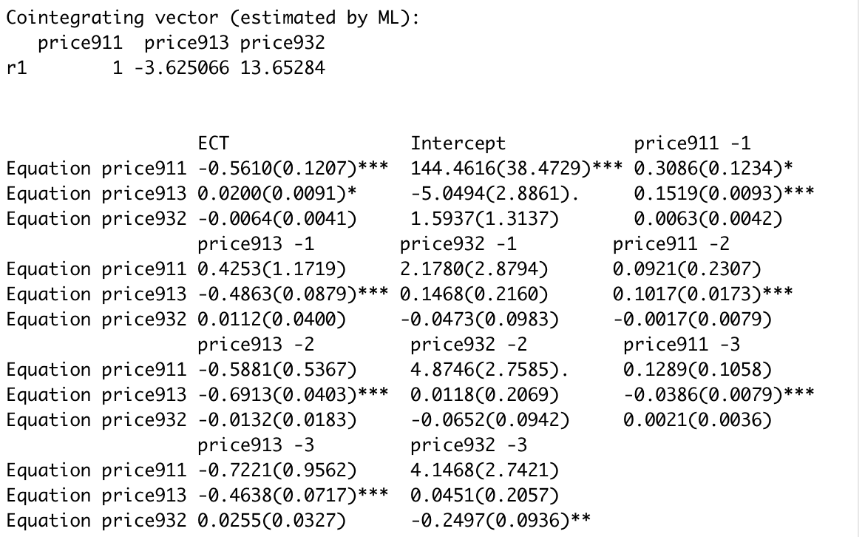
Table 8:VECM model- Wood pulp-Paper-Periodicals
(*=significant at 5%,**significant at 1%, *** significant at .01%)

Similarly in test 2, out of the three variables, the price of wood pulp (price911) is the dependent variable (r1=1) and the price of Paper (price913) and Periodicals (price932) are independent variables. The ECT is significant at 5% for paper (2.0%) indicating a long term causality. The coefficient of lag 1 of wood pulp is 0.3086, significant at 5%. For paper there is short-run causality of its own lag is indicated by the significant values at 0.01% for 3 lags.
and for periodicals, the absence of short-run causality of its own lag is indicated by the absence of significant values at 1st and 2nd lag but short-run causality of its own lag is indicated by the significant values at 1% at the 3rd lag. UNCONVINCING AND NEEDS TO BE REDONE.
However, in the case of wood pulp (price911) and periodicals (price932) out of three lags, no values are significant, indicating the absence of short-run causality on wood pulp derived from the periodicals. In the case of wood pulp (price911) and paper (price913) values are significant, indicating short-run causality on wood pulp derived from paper.

I AM UNABLE TO UNDERSTAND CLEARLY WHAT YOU HAVE DONE SINCE YOU DON’T EXPLAIN YOUR VECM PROPERLY AND DON’T EXPLAIN YOUR ECONOMETRIC STRATEGY EITHER. YOU FAIL TO EVEN DEFINE YOUR PRICE SERIES IN A TABLE.

7.Conclusion

Understanding how different market participants and external shocks might affect pricing behaviour is a crucial skill for paper market investors. External shocks can affect the market equilibrium over lengthy periods of time, allowing for rent-seeking. This study try to demonstrate how exogenous pressures such as economic forces, regulations, and natural calamities in addition to physical distance, have an impact on pulpwood and related markets. Having this knowledge might help investors decrease risks associated with price swings by promoting better resource allocation and anticipating opportunities. Prices are major factors of demand, as indicated by the economic theory. The paper industry’s co-integration relationship and short-run dynamics are studied using an error correction model. Furthermore, the model’s error correction component has a negative, substantial coefficient, ensuring a return to the long-run equilibrium if there is any short-run variation. The necessity for comparative studies to determine additional structural changes and the influence of international rules on the pricing of paper are two implications of this research for future work.
YOU HAVE NOT SUMMARISED WHAT YOUR MAIN FINDINGS ARE, WHAT RESEARCH GAP YOU HAVE ADDRESSED AND WHAT CONTIRBUTION YOUR PAPER MAKES IE WHAT HAVE YOU DONE THAT HAS NOT BEEN DONE BEFORE.

THIS CHAPTER IS CURRENTLY NOT EVEN AT MSC LEVEL – IT IS BADLY WRITTEN, POORLY STRUCTURED AND DOES NOT EXPLAIN WHAT IS BEING DONE.
THE EMPIRICAL ANALYSIS IS POOR AND THE RESULTS HAVE NOT BEEN EXPALINED OR SET OUT PROPERLY USING A SENSIBLE ECONOMETRIC STRATEGY.
YOU HAVE NOT PRESENTED A CLEAR ECONOMICS BASED THEORETICAL FRAMEWORK AT ALL AND RQS/ RESEARCH GAPS HAVE NOT BEEN CLEARLY IDENTIFIED.
THIS PAPER WOULD BE A FAIL AT MSC LEVEL AND IT IS VERY FAR FROM DOCTORAL LEVEL WORK, AND NEEDS EXTENSIVE REWRITING AND MUCH MORE CAREFUL ANALYSIS.

References

Alavalapati, J. R. R., Adamowicz, W. L., & Luckert, M. K. (1997). A Cointegration Analysis of Canadian Wood Pulp Prices. American Journal of Agricultural Economics, 79(3), 975–986. https://doi.org/10.2307/1244437
Bailey, T., Barriball, E., Sankur, A., & Dey, A. D. (2019). A practical approach to supply-chain risk management. McKinsey & Company–Our Insights.
Beaulieu, E. (2018). North American Free Trade Under Attack: Newsprint is Just the Tip of the Iceberg. The School of Public Policy Publications.
Bilotkach, V., Gorodnichenko, Y., & Talavera, O. (2012). Sensitivity of prices to demand shocks: A natural experiment in the San Francisco Bay Area. Transportation Research Part A: Policy and Practice, 46(7), 1137–1151. https://doi.org/10.1016/j.tra.2012.02.018
BPP. (2008). The Billion Prices Project. The Billion Prices Project: An Academic Initiative To Improve Macroeconomic Measurement. http://www.thebillionpricesproject.com
Bryngemark, E. (2019). Second generation biofuels and the competition for forest raw materials: A partial equilibrium analysis of Sweden. Forest Policy and Economics, 109, 102022. https://doi.org/10.1016/j.forpol.2019.102022
Buongiorno, J., & Uusivuori, J. (1992). The Law of One Price in the Trade of Forest Products: Co-Integration Tests for U.S. Exports of Pulp and Paper. Forest Science, 38(3), 539–553. https://doi.org/doi.org/10.1093/forestscience/38.3.539
Chan, S. P. (2020, April 14). “World faces worst decline since 1930s depression.” BBC News.
Chatfield, C. (1989). The analysis of time series. Chapman And Hall.
Choi, M., Dai, A. Y., & Kim, K. (2018). Consumer Search and Price Competition. Econometrica, 86(4), 1257–1281. https://doi.org/10.3982/ecta14837
Chudy, R. P., & Hagler, R. W. (2020). Dynamics of global roundwood prices – Cointegration analysis. Forest Policy and Economics, 115, 102–155. https://doi.org/10.1016/j.forpol.2020.102155
Conrad, J. L., & Bolding, M. C. (2011). Virginia’s Woody Biomass Market: Opportunities and Implications. Southern Journal of Applied Forestry, 35(2), 67–72. https://doi.org/10.1093/sjaf/35.2.67
Cord, D. J. (2021). Pulp makes much more than just paper. Pulp Makes Much More than Just Paper | UPM Pulp. https://www.upmpulp.com/media/blogs-and-stories/stories/pulp-makes-much-more-than-just-paper/
Crabtree, B. (2015). The economic contribution of the forestry sector in Scotland. CJC Consulting.
Dahal, R. P., Henderson, J. E., & Munn, I. A. (2015). Forest Products Industry Size and Economic Multipliers in the US South. Forest Products Journal, 65(7-8), 372–380. https://doi.org/10.13073/fpj-d-14-00083
Di Fulvio, F., Forsell, N., Lindroos, O., Korosuo, A., & Gusti, M. (2016). Spatially explicit assessment of roundwood and logging residues availability and costs for the EU28. Scandinavian Journal of Forest Research, 31(7), 691–707. https://doi.org/10.1080/02827581.2016.1221128
Dickey, D. A., & Fuller, W. A. (1979). Distribution of the Estimators for Autoregressive Time Series With a Unit Root. Journal of the American Statistical Association, 74(366), 427. https://doi.org/10.2307/2286348
Duden, A. S., Verweij, P. A., Junginger, H. M., Abt, R. C., Henderson, J. D., Dale, V. H., Kline, K. L., Karssenberg, D., Verstegen, J. A., Faaij, A. P. C., & van der Hilst, F. (2017). Modeling the impacts of wood pellet demand on forest dynamics in southeastern United States. Biofuels, Bioproducts and Biorefining, 11(6), 1007–1029. https://doi.org/10.1002/bbb.1803
Durocher, D. B., & Higginson, M. (2019). Thermomechanical Pulp Mill Energy Upgrade: New Technology Enhances Energy Efficiency to Reduce Operating Costs. IEEE Industry Applications Magazine, 25(5), 57–67. https://doi.org/10.1109/mias.2018.2875199
Engle, R. F., & Granger, C. (1987). Co-Integration and Error Correction: Representation, Estimation, and Testing. Econometrica, 55(2), 251. https://doi.org/10.2307/1913236
Eriksson, V., & Lundmark, R. (2020). A Cointegration Analysis of the Nordic Roundwood Markets. Forests, 11(9), 1007. https://doi.org/10.3390/f11091007
FAO. (2018). Global Forest Products Facts And Figures. https://www.fao.org/3/ca7415en/ca7415en.pdf
Ferrari, M. M., & Ters, K. (2017). Statistical implications of the new financial landscape. Irving Fisher Committee.
Food and Agricultural Organisation. (2021, December 16). FAOSTAT. Www.fao.org. https://www.fao.org/faostat/en/#data/FO
Fuhrmann, M., Dißauer, C., Strasser, C., & Schmid, E. (2021). Analysing price cointegration of sawmill by-products in the forest-based sector in Austria. Forest Policy and Economics, 131, 102560. https://doi.org/10.1016/j.forpol.2021.102560
Gejdoš, M., & Suchomel, J. (2016). Potential, Prices and Resources of Raw Wood Assortments for the Pulp and Paper Industry in Central Europe. Key Engineering Materials, 688, 210–217. https://doi.org/10.4028/www.scientific.net/kem.688.210
Giurca, A. (2020). Unpacking the network discourse: Actors and storylines in Germany’s wood-based bioeconomy. Forest Policy and Economics, 110, 101754. https://doi.org/10.1016/j.forpol.2018.05.009
Granger, C. W. J. (2004). Time Series Analysis, Cointegration, and Applications. American Economic Review, 94(3), 421–425. https://doi.org/10.1257/0002828041464669
Henderson, J. E., Joshi, O., Parajuli, R., & Hubbard, W. G. (2017). A regional assessment of wood resource sustainability and potential economic impact of the wood pellet market in the U.S. South. Biomass and Bioenergy, 105, 421–427. https://doi.org/10.1016/j.biombioe.2017.08.003
Hood, H. B., & Dorfman, J. H. (2015). Examining Dynamically Changing Timber Market Linkages. American Journal of Agricultural Economics, 97(5), 1451–1463. https://doi.org/10.1093/ajae/aau151
Howard, J. L., & Products, F. (2007). U.S. timber production, trade, consumption, and price statistics, 1965-2005. U.S. Dept. Of Agriculture, Forest Service, Forest Products Laboratory.
Hurmekoski, E., & Hetemäki, L. (2013). Studying the future of the forest sector: Review and implications for long-term outlook studies. Forest Policy and Economics, 34, 17–29. https://doi.org/10.1016/j.forpol.2013.05.005
Ince, P. J., & Nepal, P. (2012). Effects on U.S. Timber Outlook of Recent Economic Recession, Collapse in Housing Construction, and Wood Energy Trends. U.S. Department of Agriculture, Forest Service, Forest Products Laboratory.
James D. Hamilton. (2009). Causes and Consequences of the Oil Shock of 2007–08. Brookings Papers on Economic Activity, 2009(1), 215–261. https://doi.org/10.1353/eca.0.0047
Johansen, S. (1988). Statistical analysis of cointegration vectors. Journal of Economic Dynamics and Control, 12(2-3), 231–254. https://doi.org/10.1016/0165-1889(88)90041-3
Jolley, G. J., Khalaf, C., Michaud, G. L., & Belleville, D. (2020). The economic contribution of logging, forestry, pulp & paper mills, and paper products: A 50-state analysis. Forest Policy and Economics, 115, 102140. https://doi.org/10.1016/j.forpol.2020.102140
Jonsson, R. (2011). Trends and Possible Future Developments in Global Forest-Product Markets—Implications for the Swedish Forest Sector. Forests, 2(1), 147–167. https://doi.org/10.3390/f2010147
Kainulainen, T., & Toppinen, A. (2006). Testing integration in main European paper markets under floating and fixed exchange rates. Forest Policy and Economics, 9(4), 372–379. https://doi.org/10.1016/j.forpol.2005.10.004
Kanieski da Silva, B., Cubbage, F. W., & Abt, R. C. (2019). Structural Changes on Pulpwood Market in the US South: Wood Pellets Investments and Price Dynamics. Forest Science, 65(6), 675–687. https://doi.org/10.1093/forsci/fxz043
Khanal, P. N., Straka, T. J., & Willis, D. B. (n.d.). Economic Contribution Analysis of South Carolina’s Forestry Sector, 2017. South Carolina Forestry Commission.
Kittler, B., Stupak, I., & Smith, C. T. (2020). Assessing the wood sourcing practices of the U.S. industrial wood pellet industry supplying European energy demand. Energy, Sustainability and Society, 10(1). https://doi.org/10.1186/s13705-020-00255-4
Kolo, H., & Tzanova, P. (2017). Forecasting the German forest products trade: A vector error correction model. Journal of Forest Economics, 26(1), 30–45. https://doi.org/10.1016/j.jfe.2016.11.001
Kristöfel, C., Strasser, C., Morawetz, U. B., Schmidt, J., & Schmid, E. (2014). Analysis of woody biomass commodity price volatility in Austria. Biomass and Bioenergy, 65, 112–124. https://doi.org/10.1016/j.biombioe.2014.03.010
Kunttu, J., Hurmekoski, E., Heräjärvi, H., Hujala, T., & Leskinen, P. (2020). Preferable utilisation patterns of wood product industries’ by-products in Finland. Forest Policy and Economics, 110, 101946. https://doi.org/10.1016/j.forpol.2019.101946
Kwiatkowski, D., Phillips, P. C. B., Schmidt, P., & Shin, Y. (1992). Testing the null hypothesis of stationarity against the alternative of a unit root. Journal of Econometrics, 54(1-3), 159–178. https://doi.org/10.1016/0304-4076(92)90104-y
Lu, Y., Khan, Z. A., Alvarez-Alvarado, M. S., Zhang, Y., Huang, Z., & Imran, M. (2020). A Critical Review of Sustainable Energy Policies for the Promotion of Renewable Energy Sources. Sustainability, 12(12), 5078. https://doi.org/10.3390/su12125078
Martin, R., & Sunley, P. (2014). On the notion of regional economic resilience: conceptualization and explanation. Journal of Economic Geography, 15(1), 1–42. https://doi.org/10.1093/jeg/lbu015
Martino, A., Casamassima, G., & Fiorello, D. (2009). The Impact Of Oil Prices Fluctuations On Transport And Its Related Sectors. Directorate General Internal Policies Of The Union Policy Department Structural And Cohesion Policies. http://publications.europa.eu/resource/cellar/59b332d0-6bd2-4999-8fd6-6f939ab7d1f7.0001.02/DOC_1
Mei, B., & Sun, C. (2008). Event analysis of the impact of mergers and acquisitions on the financial performance of the U.S. forest products industry. Forest Policy and Economics, 10(5), 286–294. https://doi.org/10.1016/j.forpol.2007.11.005
Morrison, W. M. (2019). China’s Currency Policy. https://sgp.fas.org/crs/row/IF10139.pdf
Nepal, P., Abt, K. L., Skog, K. E., Prestemon, J. P., & Abt, R. C. (2018). Projected Market Competition for Wood Biomass between Traditional Products and Energy: A Simulated Interaction of US Regional, National, and Global Forest Product Markets. Forest Science, 65(1), 14–26. https://doi.org/10.1093/forsci/fxy031
Nycz, J. (2019, January 12). Knowing Where Your Paper Comes From: Sustainability is Critical. Woodland Paper. https://www.woodlandpaper.com/2019/01/where-paper-sustain/
Office for National Statistics. (2020, May 6). Coronavirus and the impact on output in the UK economy. Www.ons.gov.uk. https://www.ons.gov.uk/economy/grossdomesticproductgdp/articles/coronavirusandtheimpactonoutputintheukeconomy/december2020#production-industries
Palander, T., Toivonen, M., & Laukkanen, S. (2002). GroupWare and group decision support systems for wood procurement organisation. A review. Silva Fennica, 36(2). https://doi.org/10.14214/sf.546
Pesaran, M. Hashem., & Shin, Y. (1996). Cointegration and speed of convergence to equilibrium. Journal of Econometrics, 71(1-2), 117–143. https://doi.org/10.1016/0304-4076(94)01697-6
Prestemon, J. P., & Holmes, T. P. (2000). Timber Price Dynamics Following a Natural Catastrophe. American Journal of Agricultural Economics, 82(1), 145–160. https://doi.org/10.1111/0002-9092.00012
Sarker, R. (1996). Canadian softwood lumber export to the united states: A cointegrated and error-corrected system. Journal of Forest Economics, 2(3), 205–229.
Schreiber, T. (1997). Detecting and Analyzing Nonstationarity in a Time Series Using Nonlinear Cross Predictions. Physical Review Letters, 78(5), 843–846. https://doi.org/10.1103/physrevlett.78.843
Silva, B. K., Cubbage, F. W., Gonzalez, R., & Abt, R. C. (2019). Assessing market power in the U.S. pulp and paper industry. Forest Policy and Economics, 102, 138–150. https://doi.org/10.1016/j.forpol.2019.03.009
Singh, M. (2021, November 27). The 2007-08 Financial Crisis in Review. Investopedia. https://www.investopedia.com/articles/economics/09/financial-crisis-review.asp
Song, N., McLellan, I., Liu, W., Wang, Z., & Hursthouse, A. (2021). The waste ban in China: what happened next? Assessing the impact of new policies on the waste management sector in China. Environmental Geochemistry and Health. https://doi.org/10.1007/s10653-021-01101-y
Stigler, G. J., & Sherwin, R. A. (1985). The Extent of the Market. Journal of Law and Economics, 28(3), 555.
Stiglitz, J. E. (1993). The Role of the State in Financial Markets. The World Bank Economic Review, 7(1), 19–52. https://doi.org/10.1093/wber/7.suppl_1.19
Størdal, S., Lien, G., & Trømborg, E. (2021). Impacts of Infectious Disease Outbreaks on Firm Performance and Risk: The Forest Industries during the COVID-19 Pandemic. Journal of Risk and Financial Management, 14(7), 318. https://doi.org/10.3390/jrfm14070318
Strauss-Kahn, M.-O. (2020, May 5). Can we compare the COVID-19 and 2008 crises? Atlantic Council. https://www.atlanticcouncil.org/blogs/new-atlanticist/can-we-compare-the-covid-19-and-2008-crises/
Sun, C., & Zhang, D. (2001). Assessing the Financial Performance of Forestry-Related Investment Vehicles: Capital Asset Pricing Model vs. Arbitrage Pricing Theory. American Journal of Agricultural Economics, 83(3), 617–628. https://doi.org/10.1111/0002-9092.00182
Tang, X., & Laaksonen-Craig, S. (2007). The law of one price in the United States and Canadian newsprint markets. Canadian Journal of Forest Research, 37(8), 1495–1504. https://doi.org/10.1139/x06-322
Tidwell, T. (2016). State of Forests and Forestry in the United States | US Forest Service. Usda.gov. https://www.fs.usda.gov/speeches/state-forests-and-forestry-united-states-1
Tokar, T., Jensen, R., & Williams, B. D. (2021). A guide to the seen costs and unseen benefits of e-commerce. Business Horizons, 64(3). https://doi.org/10.1016/j.bushor.2021.01.002
Verkerk, P. J., Fitzgerald, J. B., Datta, P., Dees, M., Hengeveld, G. M., Lindner, M., & Zudin, S. (2019). Spatial distribution of the potential forest biomass availability in Europe. Forest Ecosystems, 6(1). https://doi.org/10.1186/s40663-019-0163-5
Wang, R., Tan, J., & Yao, S. (2021). Are natural resources a blessing or a curse for economic development? The importance of energy innovations. Resources Policy, 72, 102042. https://doi.org/10.1016/j.resourpol.2021.102042
Yin, R., Newman, D. H., & Siry, J. (2002). Testing for market integration among southern pine regions. Journal of Forest Economics, 8(2), 151–166. https://doi.org/10.1078/1104-6899-00009
Zahniser, S., Angadjivand, S., & Hertz, T. (2015). USDA ERS - NAFTA at 20: With Regional Trade Liberalization Complete, Focus Shifts to Other Methods of Deepening Economic Integration. Usda.gov. https://www.ers.usda.gov/amber-waves/2015/april/nafta-at-20-with-regional-trade-liberalization-complete-focus-shifts-to-other-methods-of-deepening-economic-integration/
Zhang, J. (2000). Sino‐US Trade Issues After the WTO Deal: A Chinese perspective. Journal of Contemporary China, 9(24), 309–322. https://doi.org/10.1080/713675935
Zivot, E., & Andrews, D. W. K. (1992). Further Evidence on the Great Crash, the Oil-Price Shock, and the Unit-Root Hypothesis. Journal of Business & Economic Statistics, 10(3), 251. https://doi.org/10.2307/1391541
‌

